CS261 ASSIGNMENT 9

NAME:

ARCHIT AGRAWAL

ROLL NO. :

202051213

SECTION:

A

1. **Write a program to illustrate sub class exception precedence over base class.**

***Approach***

Create a class ‘SuperClass’ and write a method ‘divide’ in this class which prints the integral division of two integers. This method also throws a Runtime Exception if encountered.

Create a class ‘SubClass’ and write a method ‘divide’ in this class which prints the integral division of two integers. This method throws Arithmetic Exception if encountered.

Write a ‘main’ method and create an object of the SuperClass. Call the method divide passing numerator to be some integer and denominator to be 0.

***Code***

class SuperClass{

    public void divide(int a, int b) throws RuntimeException{

        System.out.println(a/b);

    }

}

public class SubClass extends SuperClass{

    public void divide(int a, int b) throws ArithmeticException{

        System.out.println(a/b);

    }

    public static void main(String[] args){

        SuperClass obj = new SuperClass();

        obj.divide(5, 0);

    }

}

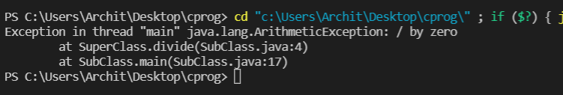***Output***

As we can see, we have encountered an Arithmetic Exception that was written in the SubClass even when we called the method of SuperClass object. Hence, the SubClass exception preceded the SuperClass exception.